CYMORTH AR GYFER EICH IECHYD MEDDWL
Gall dyfodol galluog helpu pobl a allai fod yn cael trafferthion gydag iechyd meddwl yn y gwaith. A oes angen syniadau arnynt ar sut i reoli eu hamser yn well fel bod lefelau straen yn cael eu lleihau, neu fod rhywun yn siarad â nhw am eu teimladau ar ôl i berthynas chwalu ac effeithio ar eu cymhelliant. Mae'r dyfodol galluog yn gwybod y gallai gallu cael cyngor, arweiniad a chefnogaeth ar yr adeg gywir helpu pobl sy'n gweithio ledled Cymru, Lloegr a'r Alban. Nid oes cost i ddefnyddio'r gwasanaeth hwn, dim rhestr aros ac mae'n gwbl gyfrinachol.
Os ydych yn brwydro ag anawsterau iechyd meddwl, gall hyn olygu eich bod yn cael mwy o ddyddiau gwael nag o ddyddiau da. Gallwn eich helpu i reoli eich iechyd meddwl yn y gwaith fel y gallwch fwynhau rhagor o ddyddiau da.
Yn dilyn canllawiau’r Llywodraeth ar ymbellhau cymdeithasol a chyfarwyddyd i osgoi cyswllt cymdeithasol anhanfodol fel ffordd o helpu i warchod pawb rhag coronafeirws COVID-19, mae Able Futures yn parhau i gefnogi pobl ledled Cymru, Lloegr a’r Alban drwy drefnu apwyntiadau dros y ffôn gyda’n Ymgynghorwyr Adferiad Galwedigaethol. Mae Able Futures yn parhau i ddarparu cymorth iechyd meddwl. Dros y ffôn ac e-bost, rydym yma i gynnig cyngor, arweiniad a chymorth.
Mae apwyntiadau wyneb yn wyneb wedi cael eu hatal nes rhoddir gwybod yn wahanol, ond os ffoniwch chi 0800 321 3137 neu wneud cais ar-lein am gymorth gan Able Futures, byddwn yn trefnu i chi siarad dros y ffôn, e-bost neu alwad fideo gydag YAG a fydd yn gwrando ar yr hyn yr ydych chi’n ei deimlo ac yn eich helpu i wneud cynllun ar gyfer ffyrdd o deimlo’n well.
Mae Able Futures yn darparu’r Gwasanaeth Cymorth Iechyd Meddwl Mynediad at Waith, sydd ar gael i unrhyw un sy’n gyflogedig, yn hunangyflogedig neu’n brentis, gan gynnwys unrhyw un sydd ‘ar seibiant’ (furlough), ac sydd angen cyngor ac arweiniad am unrhyw beth sy’n effeithio ar eu hiechyd meddwl yn ystod y cyfnod heriol hwn.
Os oes gennych chi unrhyw gwestiwn, cysylltwch â’ch Jake O’Mara, Rheolwr Cyfrif Busnes ar 07827 236 796 neu e-bost JAOMara@ingeus.co.uk i drafod sut y gallwn eich cefnogi chi a'ch staff orau, a derbyn ein pecyn marchnata digidol llawn gyda thaflenni, posteri, fideos a dolenni gwybodaeth.
Ydw i’n gymwys?
Gall Gwasanaeth Cymorth Iechyd Meddwl Mynediad at Waith fod ar gael i chi os gallwch ateb ‘ydw’ i bob un o’r cwestiynau a ganlyn:
_ Ydych chi’n 16 oed neu’n hŷn?
_ Ydych chi mewn gwaith/ar fin dechrau gweithio?
_ Ydych chi’n byw ym Mhrydain?
_ A oes gennych anawsterau iechyd meddwl sy’n effeithio ar eich gwaith?
Cysylltwch â ni heddiw am ragor o wybodaeth, rydym yn addo cysylltu’n ôl â chi o
fewn un diwrnod gwaith. Rhadffôn 0800 321 3137 8am i 10.30pm dydd Llun i ddydd Gwener
JAOmara@ingeus.co.uk; hello@able-futures.co.uk
Gwefan: https://able-futures.co.uk/cymraeg/coronafeirws-covid-19/?utm_source=employer&utm_medium=website&utm_campaign=EST_JOM_NWC
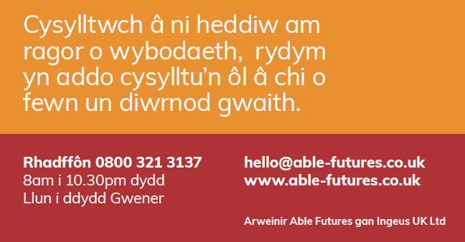
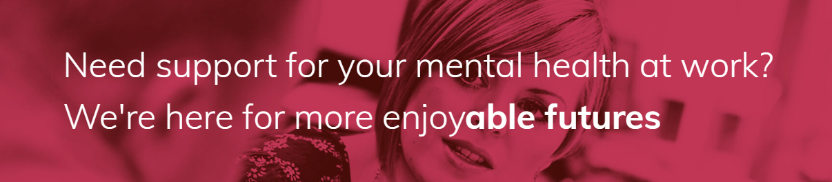

Able Futures support people who may be struggling with Mental Health at work. Whether they need ideas on how to manage their time better so that stress levels are reduced, or someone to talk to about their feelings after a relationship has broken down and affected their motivation. Able Futures know that having access to advice, guidance and support at the right time could help people who are working across Wales, England, and Scotland. There is no cost to use this service, no waiting list and it is completely confidential.
If you live with mental health difficulties, you know there are good days and bad days. You also know the bad days can affect you at work. You probably find it hard to focus or perform at your best. The aim of Able Futures is to help you enjoy more good days
Since 2018 we have supported thousands of people wanted to have more good days. Able Futures is about helping individuals learn ways to cope better with mental health challenges at work and move forward to a dependable future. Over nine months a Vocational Rehabilitation Consultant (VRC) will spend time understanding any mental health issues that are affecting a participant’s time at work, so that together they can create a support plan to move towards a more enjoyable future.
Following government guidance on social distancing and direction to avoid non-essential social contact as a way to help protect everyone from coronavirus COVID-19, Able Futures continues to support people across England, Scotland and Wales by arranging telephone appointments with our Vocational Rehabilitation Consultants (VRCs).
In light of the Covid-19 Pandemic we are able to adapt our service to ensure we can still deliver support, if you call 0800 321 3137 or apply online for support from Able Futures, we'll arrange for you to talk on the phone, via email or video call, with a VRC who will listen to what you're feeling and help you make a plan for ways to feel better.
Employers can contact Jake O’Mara, Business Account Manager for the North West and North Wales on 07827 236 796 or email JAOMara@ingeus.co.uk to discuss how we can best support you and your staff, and receive our full digital marketing pack with leaflets, posters, videos and information links. Website Link: https://able-futures.co.uk/cymraeg/coronafeirws-covid-19/?utm_source=employer&utm_medium=website&utm_campaign=EST_JOM_NWC
Enjoy more good days. Able Futures could be available to you if you can answer "yes" to the following questions:
- Are you aged 16 or over?
- Are you in work, on an apprenticeship, about to start work or furloughed?
- Do you live in Great Britain?
- Do you have mental health difficulties that impact upon your work?
*Nid yw'r rhestr hon yn gynhwysfawr*
